Homeowner Name Address

Email Phone
Structures to be painted: House Shed Other: ______________________________________________

Requested Colors (include manufacturer, color number, and sheen)

SW 6789 Satin
Example Body Color Trim Color Accent Color

Optionally, you may include a digital mock-up of your requested colors using a free paint visualizer tool online, for example: www.sherwin-williams.com/visualizer. This is not a requirement, but it will expedite the committee’s review of your request!

Color of Your Neighbor’s House (Left Side) Color of Your Neighbor’s House (Right Side)
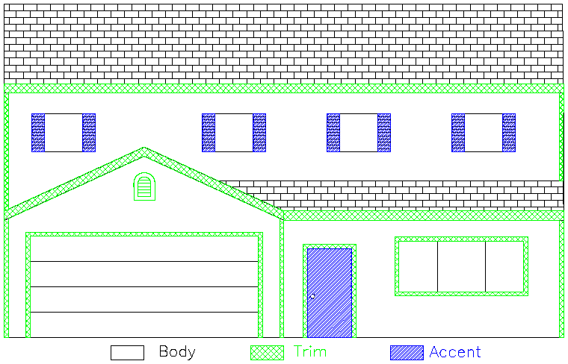
Painting Reminders:
- Each surface/area is limited to one color
- Porch must be painted the trim color
- Garage door must be painted the body or trim color; the vent above the garage should be painted the trim color but exceptions will be considered
- Changes to your original request will require submitting a new request for approval
- It is recommended to paint a 4’ x 4’ section of your home in the proposed colors for review; the HOA may require this on a case-by-case basis
- Painting guidelines are available online at https://flagstaffmanagement.com/fox-creek-farm

Homeowner Acknowledgement
I, the homeowner, understand that HOA approval must be obtained before painting starts, and the work must be completed in accordance with the information as approved.

Homeowner Signature Date

SUBMIT THIS FORM: fmc900@flagstaffmanagement.com or In-Person/by Mail: Flagstaff/FCF HOA PO Box 1004, Longmont, CO 80502

Design Committee Decision – HOA Use Only
Approved Approved with conditions; see attached Denied; see attached

Date Received Date Completed Committee Member Initials

